Live and work at Dhanakosa
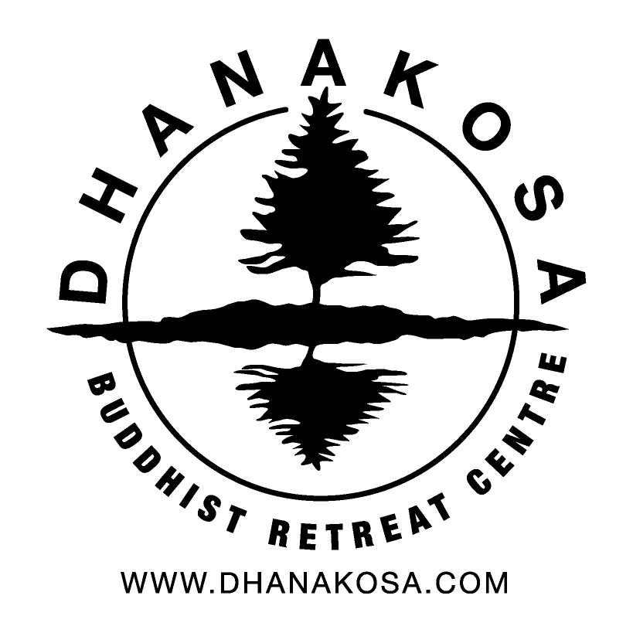
Social Media and Communications Manager and Office Team.

Closing date 2nd May 2021.

1. Personal details

Name:
Address:
Post code:

Home phone:
Work / mobile:
e-mail:

2. Involvement with Triratna

Please indicate your involvement with Triratna
Mitra
Asked for Ordination
Member of the Order

Please give a brief summary of your current involvement in Triratna activities

[expand box to fit your answer]

Please detail your previous experience of community living (if any) and say why you are interested in community living

[expand box to fit your answer]

Please detail your previous experience of team based right livelihood (if any) and say why you are interested in team based right livelihood

[expand box to fit your answer]

3. Work area and work experience

Please detail your skills and experience relevant to this role: Social Media and Communication Manager and Office Team.
[expand box to fit your answer]

Retreat team members often support other work areas. Please indicate your interests / preferences
 | I would prefer to work in these areas | I am happy to work in these areas | I am not willing to work in these areas
Admin / office
Housekeeping
General maintenance
Kitchens
Retreat organising

Do you have a current driving licence | yes | no
Any other relevant qualifications or work specific experience

[expand box to fit your answer]

Please also enclose a one page CV and feel free to enclose an additional covering letter if you that helps you include any relevant information not captured in the form.

4. Referees

Please provide contact details for two references. At least one whom is a member of the Triratna Buddhist Order.

If you would like to discuss any aspect of your interest in joining the Dhanakosa team, or any other issues regarding your application please e-mail nayaka@dhanakosa.org or phone 01877 384 213 asking for Nayaka.

Please return this form by e-mail to nayaka@dhanakosa.org , or post to:

Nayaka
Dhanakosa
Balquhidder
Lochearnhead
FK19 8PQ

Thank you for your interest in coming to live and work with us.

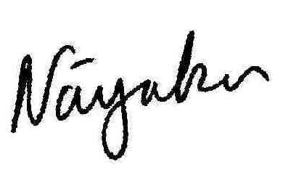
Centre director.

