Crotha Bothy
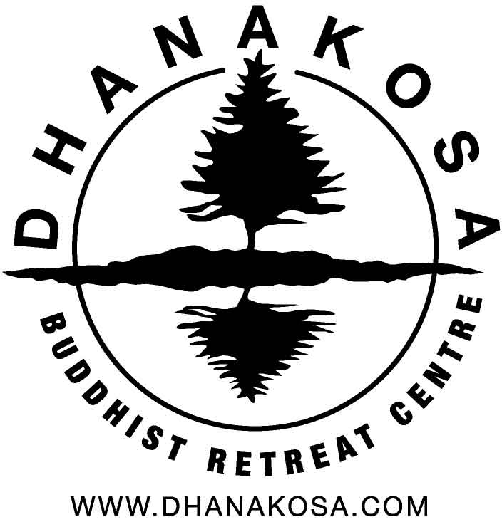
Solitary retreat application form

Solitary retreats can at times be psychologically and emotionally stressful, particularly in an environment as isolated and challenging as the Bothy. To better help us understand your ability to undertake a long solitary retreat, please provide us with the following information.

Please complete and return to: info@dhanakosa.com

Personal details
Name: ________________________________________________________________________________________________________________________________________________________
Address: ________________________________________________________________________________________________________________________________________________________
________________________________________________________________________________________________________________________________________________________
Home Phone: _______________________________________ Mobile: _______________________________________
Email: ___________________________________________________________________
Date of Birth: _______________________________________ Gender: Male _________ Female __________
Emergency contact details (name & telephone number(s) of someone we can contact in case of emergency):

________________________________________________________________________________________________________________________________________________________

Health and welbeing

In answering these questions please remember that you will be living in an isolated location without mobile phone reception, with a very limited electricity supply and an hour’s walk from Dhanakosa. The Bothy can be snowbound any time between November and April depending on the conditions that year.

Any information given in this section will be treated in confidence. If you are unsure please talk to us and we will work with you to find out whether or not the retreat you are proposing is an advisable undertaking or not.

- Staying at the Bothy involves a range of physical tasks, including lifting 25kg bags of coal, chopping kindling and carrying supplies 300m up a steep and rough track in all weather conditions. Please comment on your physical fitness, practical competence and any other relevant experience.

- Robust emotional and mental health is an important pre-requisite for a successful solitary retreat. Please let us know if you are currently or have at any time in the last three years been prescribed medication to help you with your emotional or mental health or to help with an addiction problem.

- Please let us know if feel you have any reason to be concerned about your mental or emotional health.

Previous retreat experience

- Which practice centre(s)/group(s) are you affiliated with?

- Pease give dates and duration of previous meditation retreats and solitary retreats

- Can you briefly summarise your intentions for this solitary retreat at Dhanakosa

For longer retreats it is important that we are able to verify that you proposed undertaking is reasonable given your experience of practice. To do this we would like to be able to contact Order Members of the Triratna Buddhist Order (for people practicing within the Triratna Buddhist community), or a teacher from your own practice community who knows you and is able to vouch for you.

Please give contact details for at least one Order Member/teacher below.

Thank you

